Company User Online Account Quick Reference Guide
Company user online account is accessed at www.sibbaldtraining.com/my-account/
Login details to access your company account are requested by contacting: enquiries@sibbaldtraining.com and once enabled your email address is the username for the system and the password can be requested through the Forgot Password link when logging into your account online
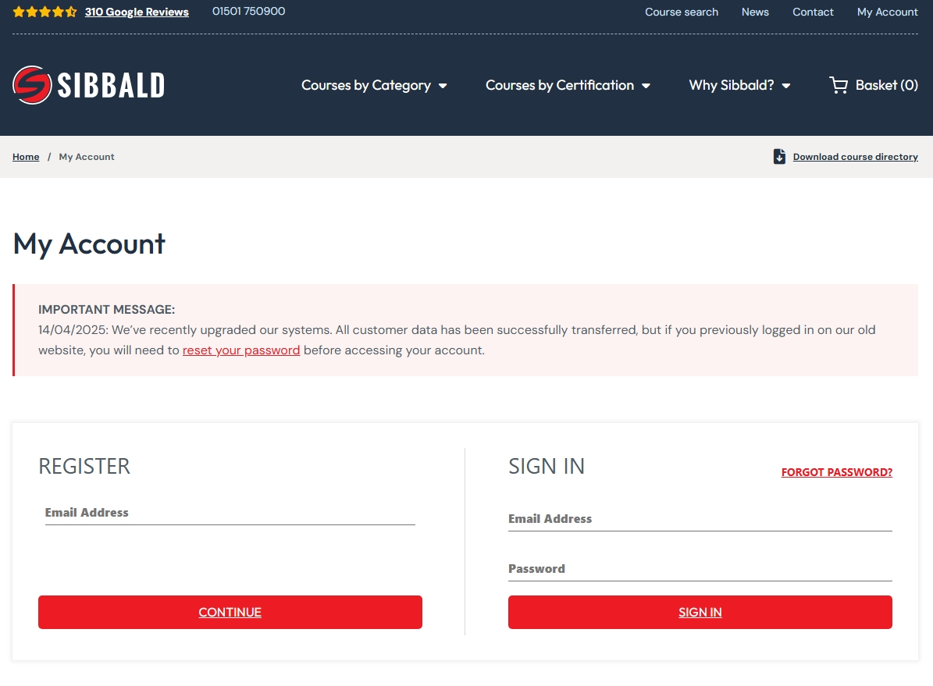
Enter Email Address & Password
‘My Account’ to Login
Company User Online Account Quick Reference Guide
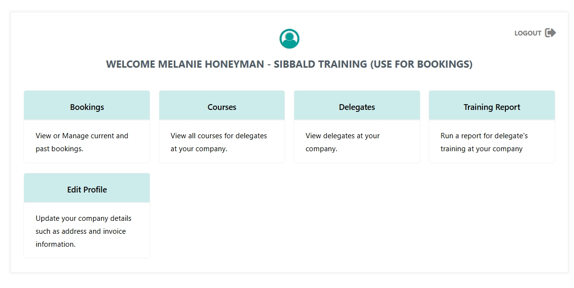
BOOKINGS allows invoices to be viewed downloaded
Payment Status displays the status for each booking
You can view delegates assigned to the training or be added if not completed at time of booking and joining instructions to be resent
DELEGATES is used to view and update information held against each delegate
Clicking into the delegates name allows information held against each delegate to be edited.
Storage allows for all certification held against each delegate to be downloaded and viewed.
TRAINING REPORT provides an overview of the status of each course booked (attended/pass/fail)

Edit Profile allows you to edit your details, company address and invoice address details.
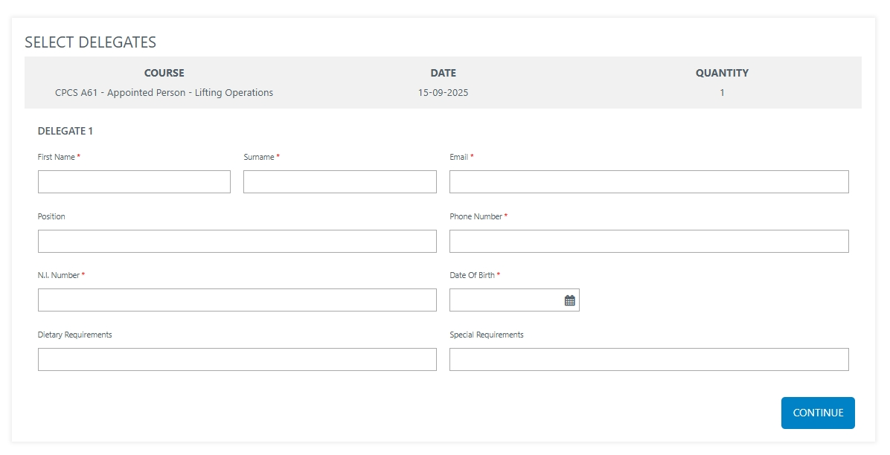
Company User Online Account Quick Reference Guide
Booking Process
- Select the courses required and add to cart
- Click on Checkout
- Delegate details page is shown.
- If you do not have the delegates full details at this point you can click continue without submitting any details, but these must be provided before the training takes place.
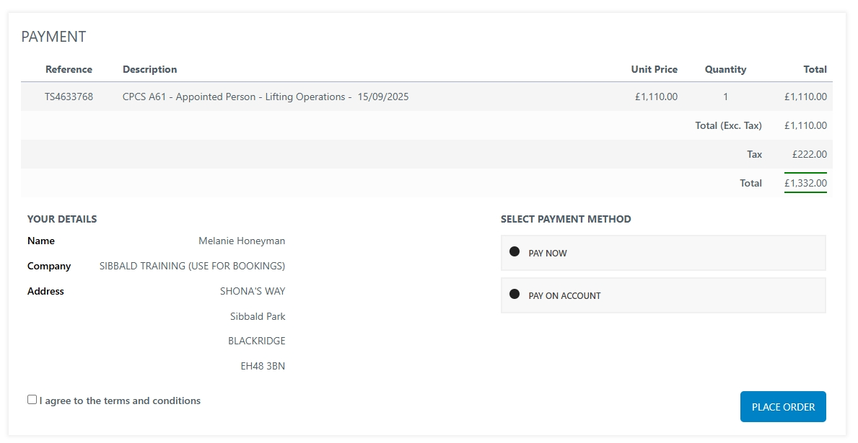
Payment Process
- Select Payment Options:
Pay on Account links payment to your company credit account- Please enter a Purchase Order number.
Pay Now allows online secure checkout by credit card payment.

- Agree to the Terms and Conditions.

- Place Order

Company User Online Account Quick Reference Guide
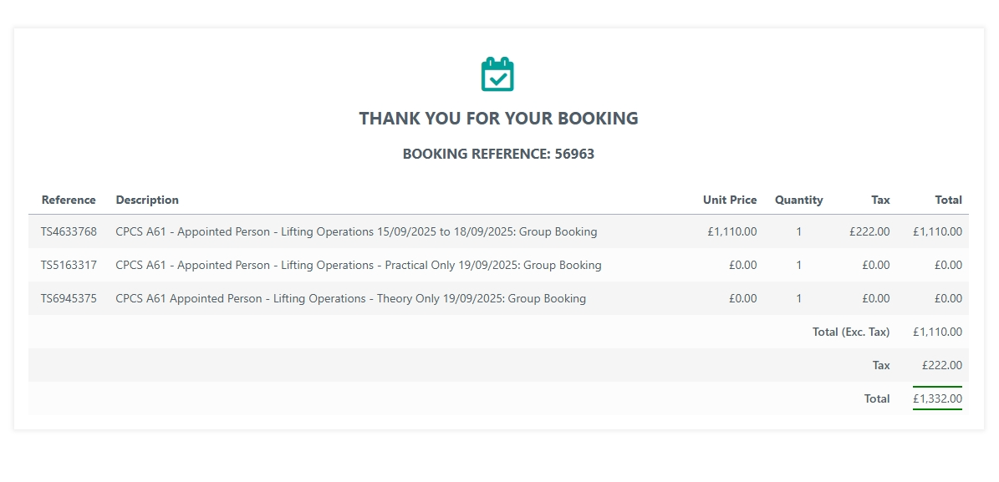
Order confirmation will be Displayed with the booking reference.
You can add the details of the delegate attending training within the booking section of the main dashboard

5. Joining Instructions and order confirmation will be sent to the bookers email

6. Once course or delegate details are confirmed any changes to bookings can be completed by contacting: 01501 750900 or enquiries@sibbaldtraining.com

